1. Power BI Auto-Created Data Model
In the first image, the data model represents the initial schema automatically created by Power BI after loading the datasets. The model follows a star-schema–like structure, where fact tables are connected to multiple dimension tables.
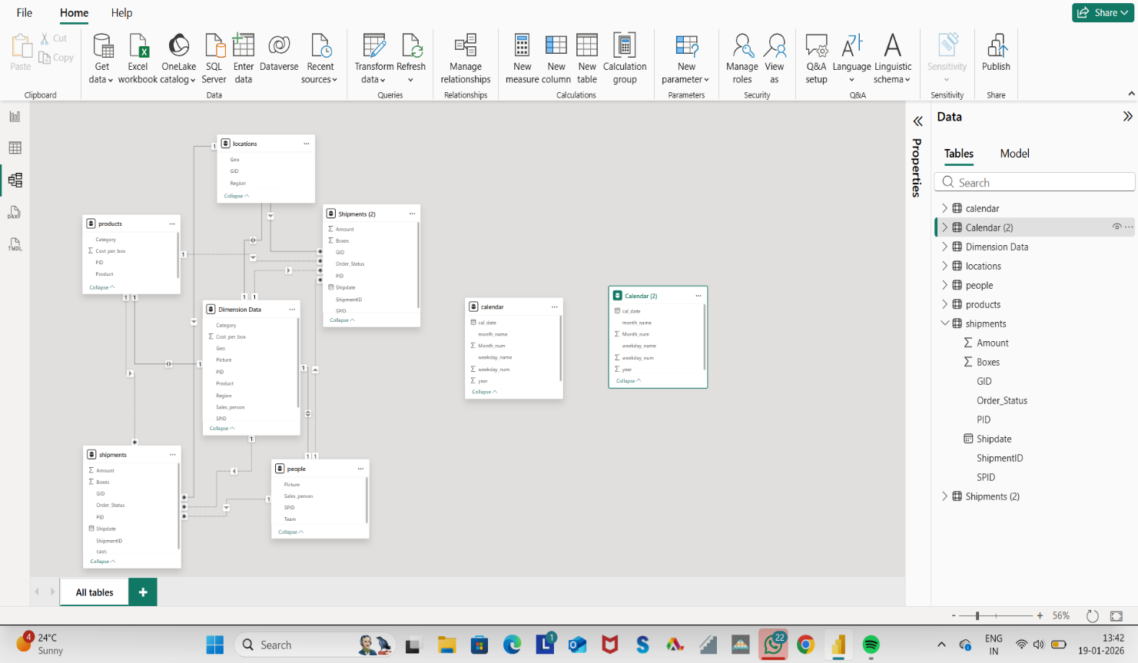

2. Custom Relationship Model Using Calendar & Calendar (2)
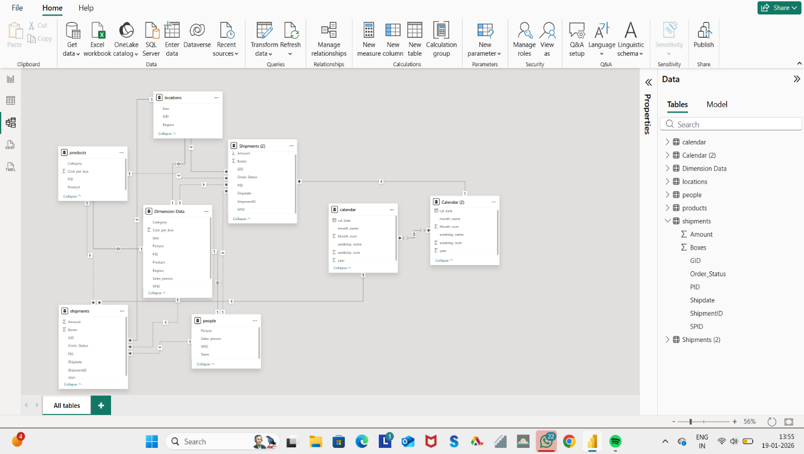

In this image, the data model is enhanced manually by creating two separate date relationships:

